Supporting Information

Nanofluidic optical diffraction interferometry for detection and classification of individual nanoparticles in a nanochannel

Yoshiyuki Tsuyamaª* and Kazuma Mawatari^{a,b}*

a. Department of Bioengineering, Graduate School of Engineering, The University of Tokyo, 7-3-1, Hongo, Bunkyo, Tokyo 113-8656, Japan
b. Department of Applied Chemistry, Graduate School of Engineering, The University of Tokyo, 7-3-1, Hongo, Bunkyo, Tokyo 113-8656, Japan

*Corresponding authors: Tel: +81-3-5841-8582

Email: ytsuyama@g.ecc.u-tokyo.ac.jp
kmawatari@g.ecc.u-tokyo.ac.jp

Table of Contents:

- Average signal intensity versus diffracted light intensity (Figure S1)
- Intensity distribution of pulse signals for 30 nm gold nanoparticles (Figure S2)
- Optical system and example of signals for dual-wavelength measurement (Figure S3 and S4)
- Accuracy score for Support vector machine (SVM) classification (Figure S5)
- Theoretically calculated values of scattering, absorption, and interferometric scattering for 40-nm gold and silver nanoparticles (Table S1)
- Procedure of classification of four types of nanoparticles using machine learning
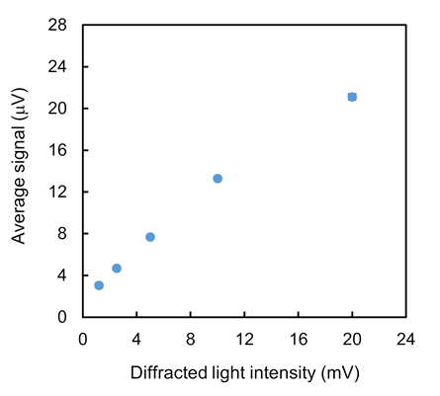
Figure S1. Average signal intensity for 1 min measurement versus diffracted light intensity. Diffracted light intensity was measured by intensity modulation of illumination laser and lock-in detection.

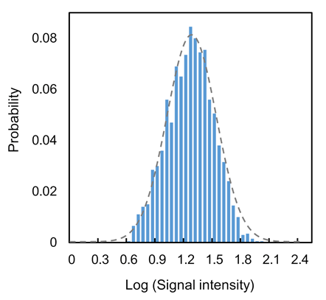
Figure S2. Intensity distribution of 2000 pulse signals for 30 nm gold nanoparticles. The bin width was set to 0.05.

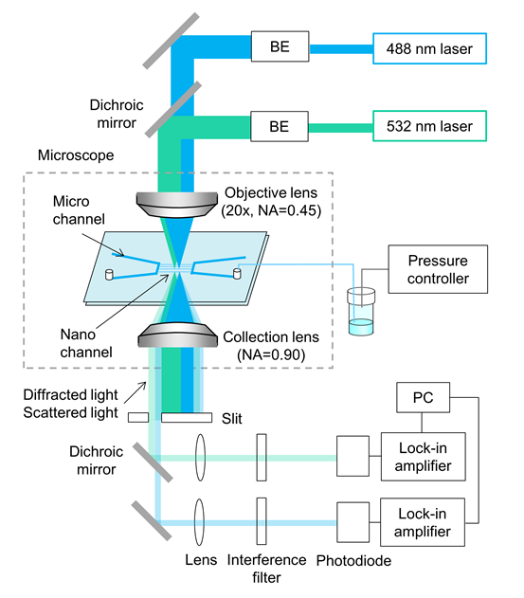
Figure S3. Optical system for dual-wavelength measurement. Two lasers were super-positioned by a dichroic mirror and focused on a nanochannel. Diffracted and scattered light for each wavelength were separated by a dichroic mirror and detected by a photodiode and a lock-in amplifier, respectively.

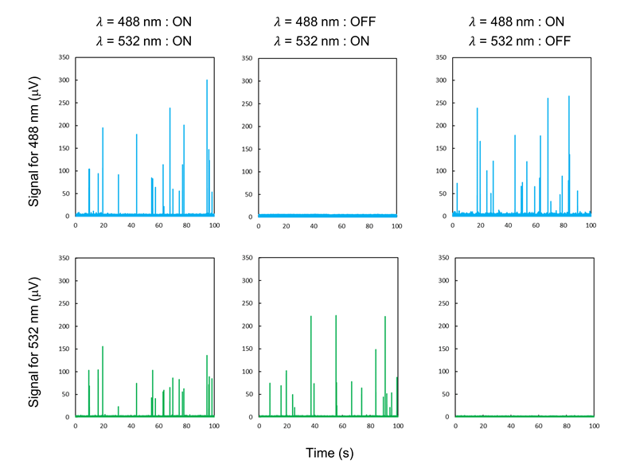
Figure S4. Example of signals for dual-wavelength measurement. Interferometric signals were observed only when irradiated with a laser, suggesting no signal crosstalk.

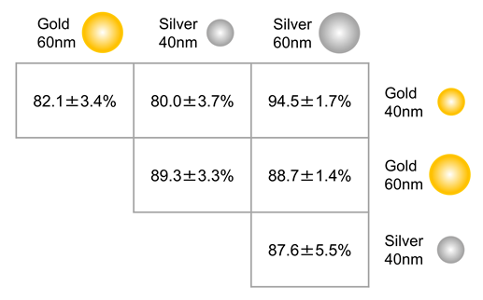
Figure S5. Accuracy score for classification of two types of nanoparticles. Support vector machine (SVM) algorithm in the scikit-learn library of the Python programming environment was used (Python Software Foundation, Wilmington, DE, USA). Each accuracy score was calculated from the average of 10-fold cross-validations.

Table S1. Theoretically calculated values of scattering, absorption, and interferometric scattering for 40-nm (a) gold and (b) silver nanoparticle. The value of refractive index and extinction coefficient are according to the literature values [1]. Theoretical values for interferometric scattering were calculated as a square root of those for pure scattering.

- Gold
Wavelength | Refractive index | Extinction coefficient | Scattering  (Cross section) | Absorption  (Cross section) | Interferometric  scattering
488 nm | 1.04 | 1.833 | 0.20 | 2.21 | 0.45
532 nm | 0.62 | 2.081 | 0.46 | 3.44 | 0.68
660 nm | 0.14 | 3.697 | 0.10 | 0.10 | 0.32

- Silver
Wavelength | Refractive index | Extinction coefficient | Scattering  (Cross section) | Absorption  (Cross section) | Interferometric  scattering
488 nm | 0.05 | 3.093 | 0.72 | 0.15 | 1.90
532 nm | 0.05 | 3.324 | 0.37 | 0.085 | 0.89
660 nm | 0.05 | 4.483 | 0.07 | 0.016 | 0.85

Procedure of classification of four types of nanoparticles using machine learning

- Measuring 400 counts of signals for four types of plasmonic nanoparticles, respectively.
- Preparing 1600 datasets of the four feature parameters (signal height and width for 488 nm and 532 nm excitation) and corresponding true labels (indicates the type of particle).
- Dividing into train data and test data with a 75:25 train/test split.
- Training the Support vector machine (SVM) classifier by 10-fold cross-validations.
- Optimizing hyper-parameter based on the average accuracy ratio. (In this study, Radial basis function kernel was chosen, and the cost parameter and kernel parameter were set to 1.0 and 0.1, respectively.)
- Evaluating the performance by confusion matrix for the test data.

